Branching, Merging, and GitLab Requests

# 1. Branching and Merging in Git

## What is Branching?

Branching in Git allows developers to create separate lines of development within a project. A branch is like a parallel version of the codebase where you can work independently without affecting the main (usually 'master' or 'main') branch.  
  
• The default branch is usually 'master' or 'main'.  
• You create a new branch to add new features, fix bugs, or test ideas.  
• Each branch has its own commit history, allowing clean separation of work.

Example:

git branch feature-branch  
git checkout feature-branch

## What is Merging?

Merging is the process of combining the changes from one branch (e.g., 'feature-branch') into another branch (e.g., 'master'). This happens after the development is complete and tested.  
  
• Git identifies the differences and merges them into the target branch.  
• If there are conflicting changes, Git prompts for manual resolution (can be done via tools like P4Merge).

Example:

git checkout master  
git merge feature-branch

# 2. Creating a Branch Request in GitLab

Note: GitLab doesn’t use the term 'branch request' officially — but it usually refers to creating a new branch in GitLab via the web UI or pushing a local branch to GitLab for collaboration.

## Option A: Create a branch locally and push to GitLab

git checkout -b new-feature  
# make changes, commit them  
git push origin new-feature

## Option B: Create branch directly in GitLab UI

1. Go to your GitLab repository.  
2. Navigate to Repository > Branches.  
3. Click 'New branch'.  
4. Name the branch and choose the base (e.g., 'master').  
5. Click 'Create Branch'.

# 3. Creating a Merge Request in GitLab

A Merge Request (MR) in GitLab is used to propose merging one branch into another — similar to a pull request in GitHub.

Steps to Create a Merge Request (MR):  
1. Go to your GitLab repo.  
2. If you’ve recently pushed a branch, GitLab often shows a prompt to create a merge request.  
3. Or go manually to Merge Requests > New Merge Request.  
4. Select source and target branches (e.g., GitNewBranch → master).  
5. Add a title, description, and optional reviewers.  
6. Click 'Create merge request'.  
7. After review, click 'Merge' to complete.

# Summary Table

|  |  |
| --- | --- |
| Concept | Description |
| Branching | Creating a separate line of development to work independently |
| Merging | Combining changes from a branch into the main branch |
| Branch Request | Creating or pushing a new branch to GitLab for collaborative work |
| Merge Request | A GitLab feature to review and merge changes from one branch into another |

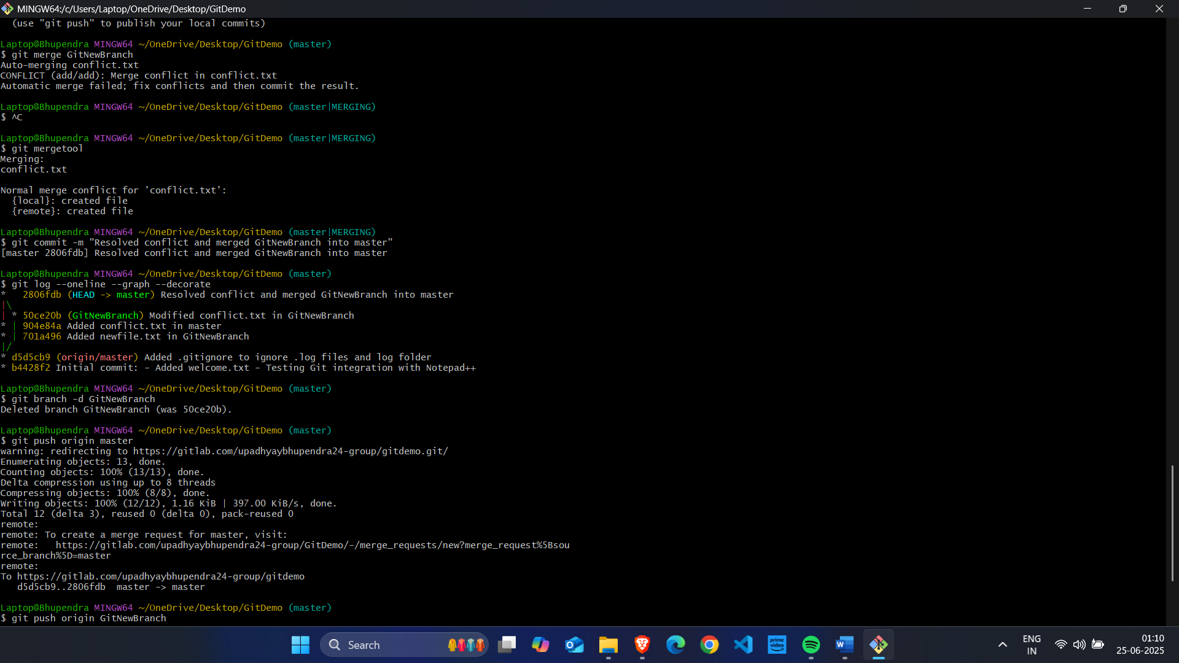

* GitLab repo link: https://gitlab.com/upadhyaybhupendra24-group/gitdemo

